Name Of The Project:

MECHA-MARU mk-III (wi-fi controlled autonomous tank)

AUTHOR & MAKER:***Souradeep Atar, B.Tech CSE, I.E.M., Kolkata, 700091 (7557064471,atarsynthesis007@gmail.com)***

Abstract:

In this paper I showcase my project prototype named “MECHA-MARU mk-3” which is an Autonomous Wi-Fi Controlled Robotic Tank and talk about it’s development procedure. The aim is to develop a completely independent, reliable and robust system that may find it’s prospect in the near future.

This tank comes equipped with an automatic rapid fire canon, which is mounted on its main artillery socket and can move and aim freely along both the axes. The canon will be upgraded to a more powerful one in the next prototype.

Keywords: Autonomous, Wi-Fi controlled, Tank, Canon, rapid-fire, upgrade

Introduction:

The origin of the name “Mecha-Maru” is Japanese.

The word **Maru** (丸, meaning "circle") is often attached to Japanese ship names. Several theories purport to explain this practice. The most common is that ships were thought of as floating castles or fortress, and the word referred to the defensive "circles" or maru that protected the castle.

The term **Mecha** (メカ, Hepburn: meka) may refer to both scientific ideas and science fiction genres that center on giant robots or machines (mechs) controlled by people. Mechas are typically depicted as humanoid mobile robots. The term was first used in Japanese (meka) after shortening the English loanword mekanikaru ('mechanical'), but the meaning in Japanese is more inclusive, and "robot" (robotto) or "giant robot" is the narrower term.

This is the third working prototype and a fully functional one.

Well naming aside let’s talk about the actual project !

In this paper I introduce the Autonomous Wi-Fi Controlled Robot Tank, which can be controlled and maneuvered using our everyday friendly smart phones. The tank is still in its development stage and will later be fitted with various sensors and mapping equipment such that it can maneuver itself on its own. Now it can maneuver itself with some human assistance.

The tank has a 4-wheel Drive system and can be driven in almost all terrains with little adjustment to its wheels and track.

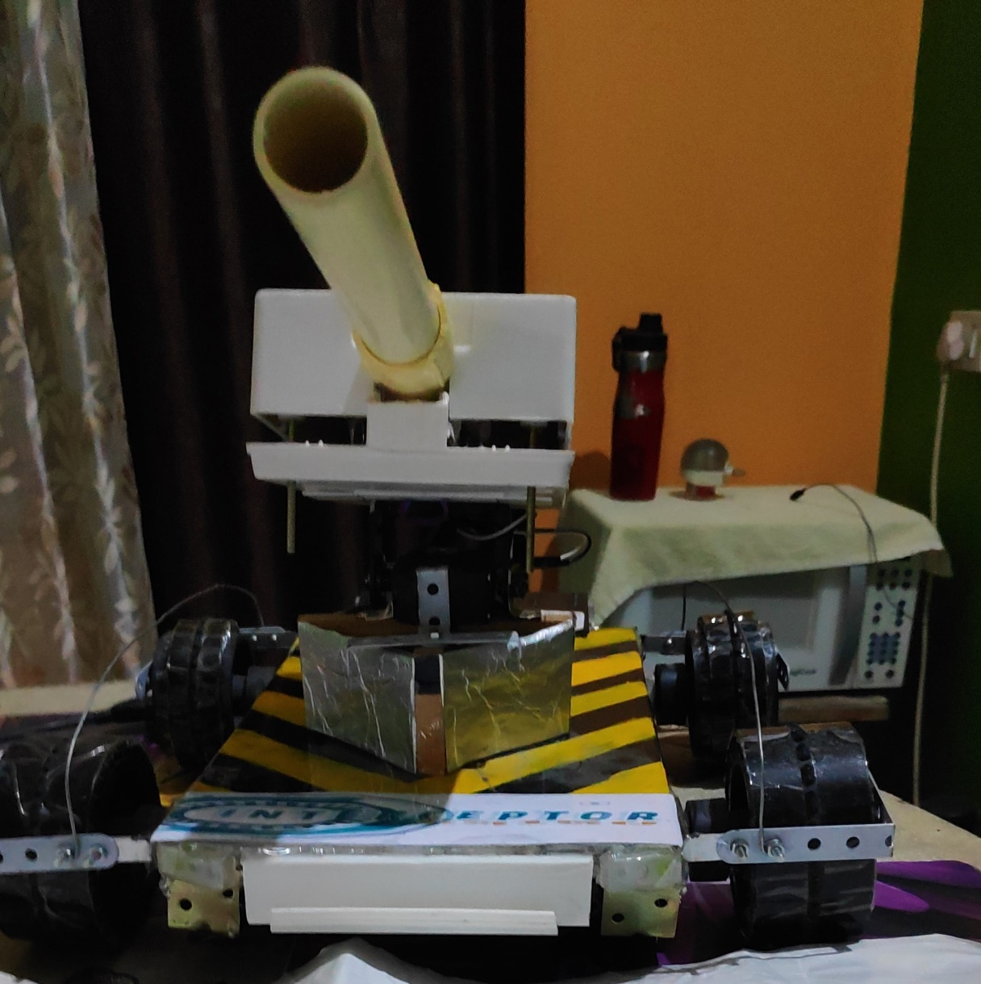

The turret of the tank consists of a rapid-fire automatic canon which can fire 3 cartridges/sec and instantly empties it’s barrel. It runs on a lead acid battery and one charge can last up to 10-15 minutes. Its top speed is 9 km/hour. It weighs around 4kgs and it’s maximum payload is 2kgs.

The reason for working on this project and developing the prototype is to construct an indigenous unmanned drone vehicle for military reconnaissance and to provide the Indian military the necessary support in battlefields. The future developments will make the model more robust. The project will definitely meet The “Make In India” Standards.

**DEVELOPMENT:**

After working on the first few designs and actually making a first prototype in my high school for my physics project was quite challenging since my high school at that time didn’t had any dedicated robotics lab or ATL’s. Getting parts was the main problem since I had no access to 3D printers (even now because the project is self-funded at the moment). Finding proper electronics and figuring out how they work without any prior knowledge and experience was another hassle (since this is my first complex machine). I used wooden parts as substitute to printed parts but making them were like pieces of a puzzle a lot of wood glue and a lot of cutting and sawing that’s all. Miraculously the first prototype was a success even though it had a few problems, my teachers and friends really liked it.

The turret of the 1st prototype was gas propelled. I had used acetylene(water+carbide) as the explosion media and a nichrome wire to ignite the gas inside the barrel of the canon. Hence it was a one shot per load.

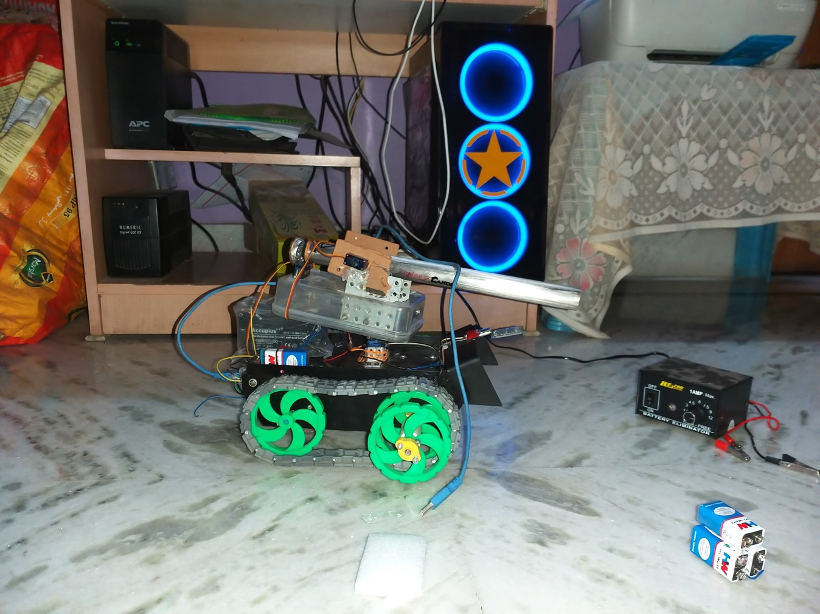

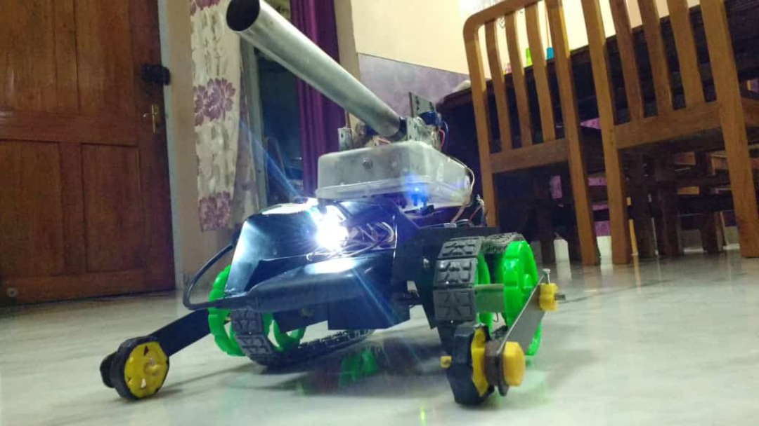

The pictures of the 1st prototype

The second prototype had the same body as the present one but the electronics were similar to the first one. The main focus of this prototype was to develop an automatic canon (the present one that I am using). The turret is made up of PVC pipe and PVC housing.

It has 4 motors- 2 for propelling the cartridge out of the barrel and 2 for rapid fire which means it will push another cartridge towards the propelling motors after one has been fired.

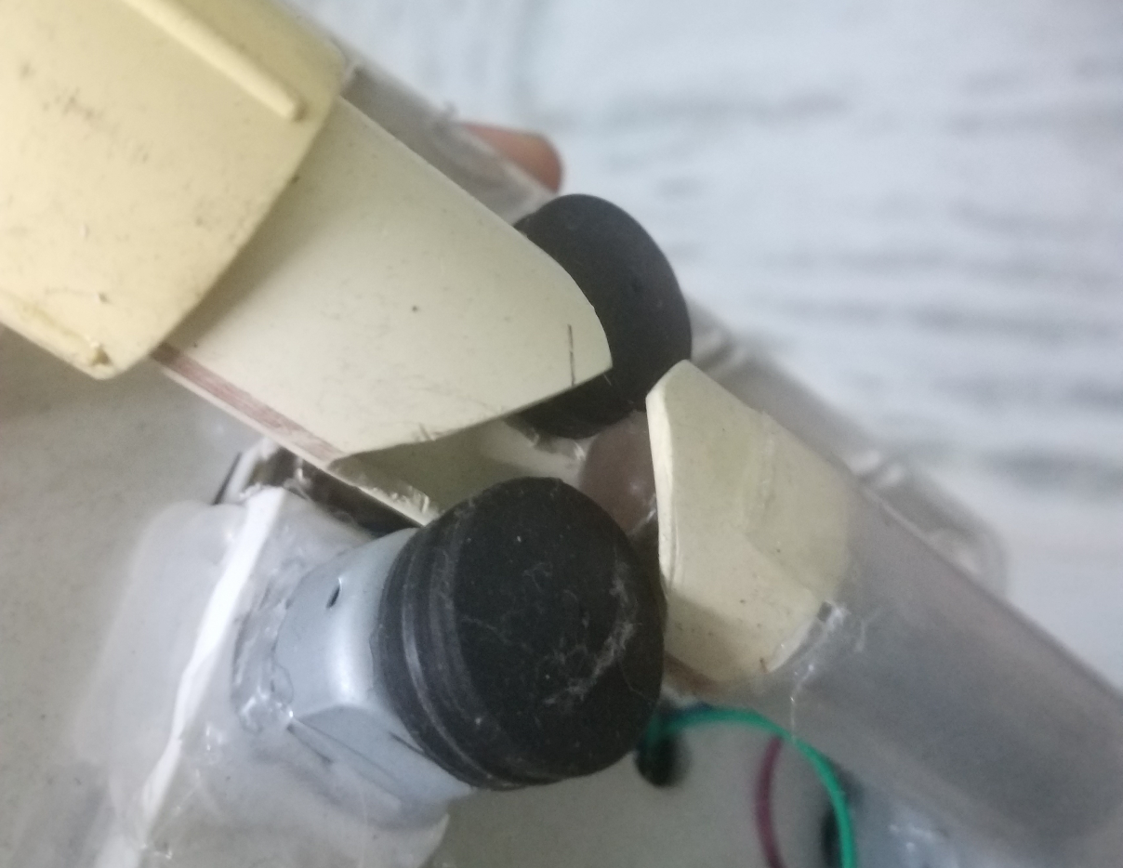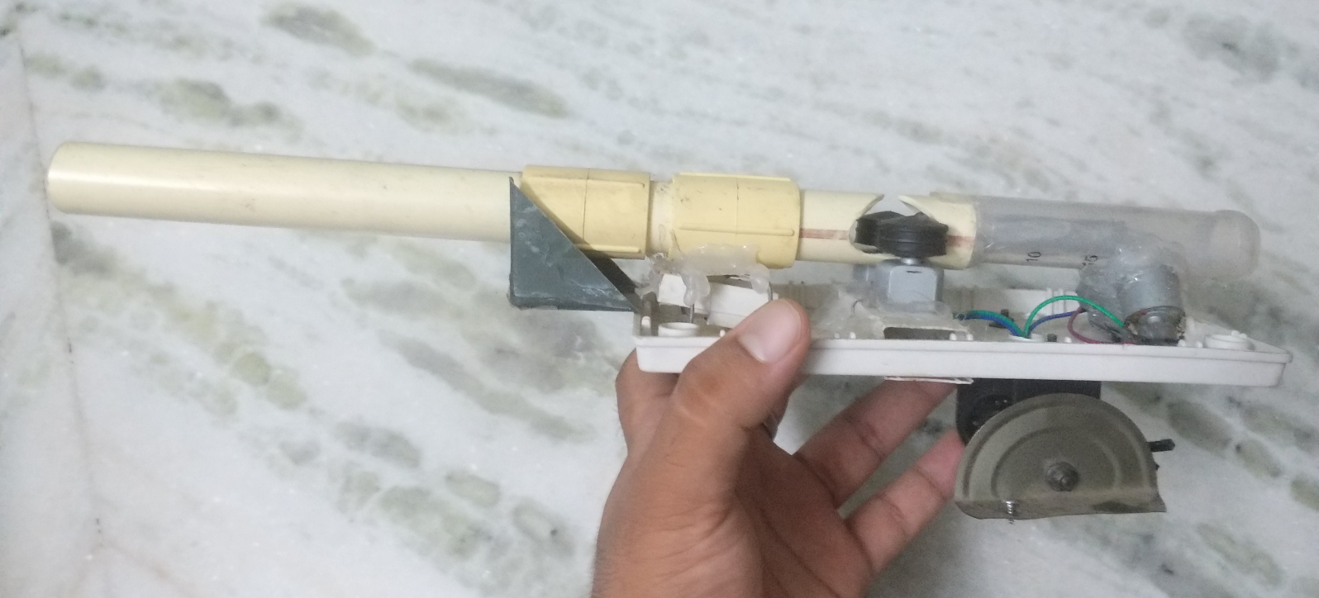

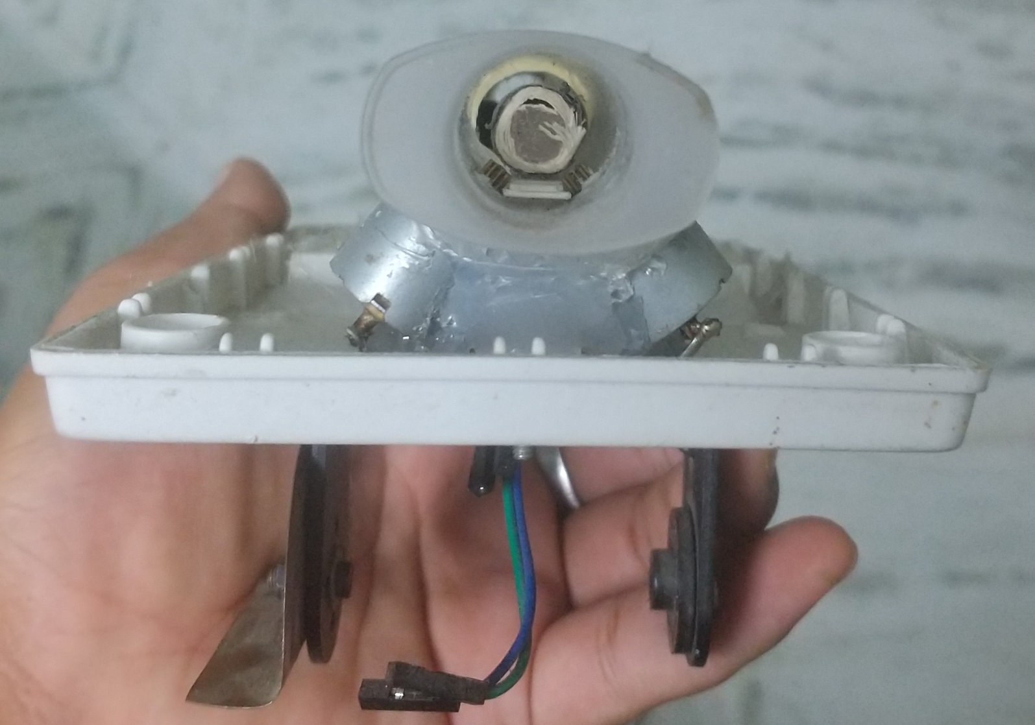

Pictures of inside the turret

Note: I am still surprised by thinking how much effort it took for me to carve out the parts by hand through cutting and sanding.

The third prototype(The current one), has had change in electronics. Previously I was using a Bluetooth module as its receiver and L293D motor driver shield which are beginner type electronics. This time I decided to upgrade to an ESP8266 Node-MCU Wi-Fi Receiver for a greater range and low latency and two L298N motor driver modules which has a greater current load. It worked well but the tank was too heavy for the motors to handle it(I was out of budget so had to use cheap 100 rupees motors, the powerful ones cost over 500 rupees each), so I decided to increase the voltage supplied to the motors, which in fact worked but it came at a price of putting too much strain on the motor driver so I kept the voltage to a level which would be better for both(but motor drivers decreased its efficiency over time), but it worked!

At least.

Next up was tuning the servos. I ran out of PWM pins on the Arduino uno so I used some of the free analog pins to generate PWM signals but they couldn’t handle large servos very well. Hence use Arduino UNO only for beginner level projects and use larger microcontrollers like Arduino Mega for complex projects like this so that you never run out of gpio pins!

The rest, I worked on the power distribution system of the tank and the overall looks and aesthetics.

Components:

ELECTRONICS:

1. **Arduino UNO R3:**

The robot is an arduino microcontroller based rover with arduino UNO as the heart of the tank.

1. **ESP8266 Node-MCU:**

To Serve as the wi-fi Receiver for the tank the Node-MCU is used which has its own logic microcontroller. It acts as the bridge between your smartphone and the tank.

1. **L298N Motor Driver board:**

The signal generated by the Arduino UNO needs to be converted into a way to drive the motor. The L298N IC is based on H-bridge Logic which can drive the motor in both clockwise and anti-clockwise directions.

1. **300 RPM geared down motor:**

Geared down motors provide lower speeds with higher torque, which in this case is ideal and cheapest way for driving a heavy tank.

1. **XL6009 DC-to-DC Buck converter:**

To step down(while stepping up current) or step up(while stepping down current) the voltage a buck converter is required. It helps to supply the needed voltage to the motors.

1. **12 volt mini Lead-Acid battery:**

To act as a power source and power the entire electronics of the system a 12v lead-acid battery acts as an ideal and the cheapest way to do so. It can supply a steady voltage throughout with very little fluctuations and can last a decent amount of time.

1. **1N4001 rectifier Diodes:**

There is always a risk of *back emf*  in the circuit due to the forcible rotation of the motor shaft in the non-desired direction, which could always damage the circuit. To overcome this problem a protection circuit is incorporated into the design to prevent device malfunction or breakdown. This feature is known as ***Back EMF protection*** which can easily be achieved by using diodes in a two-way rectifier pattern for each motor terminal.

1. **SG-90 micro Servo & MG-995 Servo:**

For movement of the turret in both the axes, 2 servo motors are used to rotate the turret 1 for each axis.

1. **4-port USB hub & 2.1 ampere power bank:**

Some components in the system needs a steady standalone 5 volts power supply. So a high current power-bank is used and it’s power is split with a 4-port usb hub among the circuitry.

BODY OF THE TANK:

* A full steel body is uses as the chassis of the tank
* A wooden cross-support is used to support the turret
* Servo brackets are used to attach the canon to the servo
* Couplers are used to mount the brackets to the output shaft of the servo motor
* Wooden anti-bending supports to add rigidity to the metal chassis
* Anti-Rat cover which protects the internals of the tank

DISCUSSION:

The Fields where this Tank Can Be Used:

The future versions of this tank can be used in various purposes.

It can be used by the military for reconnaissance, can also be used as a spy robot. The canon can be fixed with suitable artillery. It can also carry bombs as payload which will make it a movable doom.

The robot can also be used just for fun! It can battle and race with other robots.

The version of the tank with caterpillar tracks is terrain independent and can move freely in any terrain.

FUTURE UPGRADES AND IMPROVEMENTS

I have planned a lot for the next prototype (Mk-4) of this tank. Since I am an engineering collage student, I will get access to various modern equipment available at collage for example a 3D-printer, a lathe machine, a milling machine, etc. So my next upgrade will be my electronics and motors. I have planned to use The Cycloidal Drive gearbox which will have an adjustable gear ratio and can also be back driven and will provide ample force to drive the heavy tank as smooth as butter.

I also plan on a significant weight reduction of the tank on the next prototype. I am currently designing a low weight metal skeleton for the tank which will later be covered with sun boards or plastic. Also instead of using a lead acid battery which is the heaviest part I will be using a low weight high density lithium-Polymer(Li-Po) batteries.

The upgrades for the 5th prototype will be its canon. I plan on making a railgun or a coil-gun (if I find any suitable partner, By the way I am currently doing the project solo)

And maybe in Future, I plan on making a full Size tank by modifying a used car.

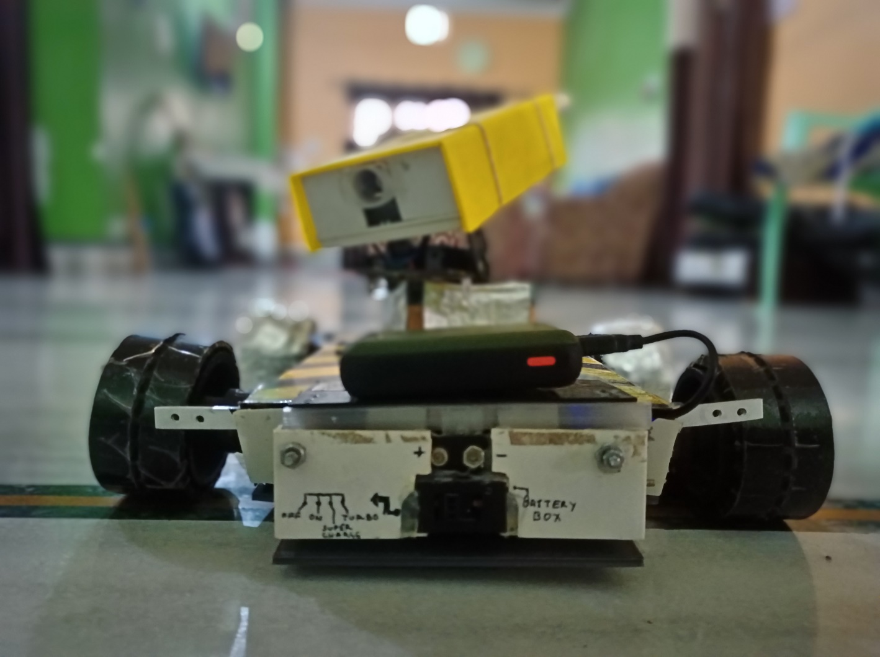

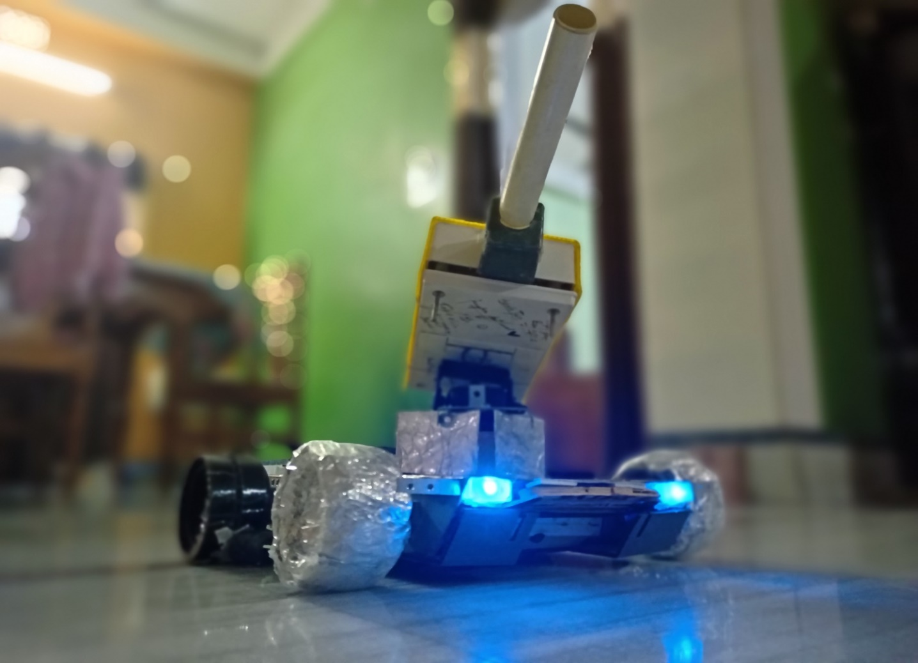

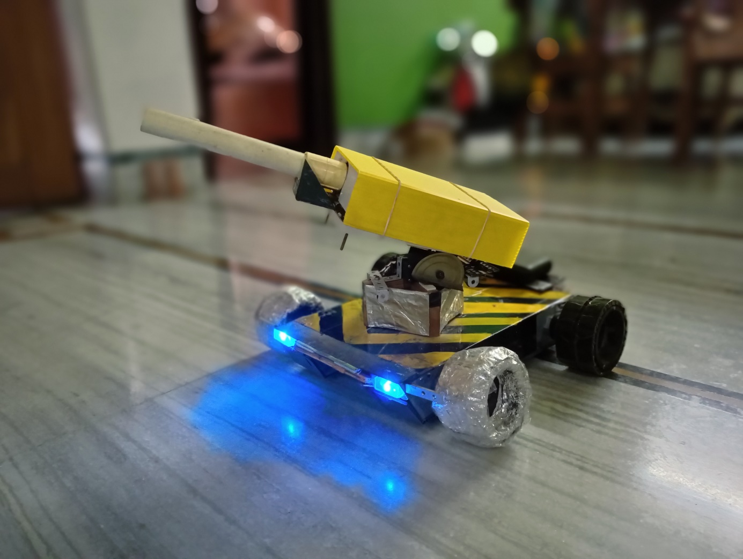

To check out the video of the canon firing, open the link below:

<https://drive.google.com/file/d/1atIWFlY0vas52QVFApa0wihVolQDyyev/view?usp=drivesdk>

Check out the full video of the tank in action from the link below:

<https://drive.google.com/file/d/1_lUfbZWz-vQXdnm_bvVl0gIFM9Wbu1wZ/view?usp=sharing>

REFERENCES:

[www.wikipedia.org](http://www.wikipedia.org)

[www.instructables.com](http://www.instructables.com)

git Hub